Vita Deutsch / English 24 January 2017
Zsuzsa Domonkos  Geboren und zur Kunsterzieherin ausgebildet in Budapest, finde ich Freude an Musik und Bewegung, und am Zeichnen und Malen.  Wenn die Kinder unverbildet ihr kreatives Potential entdecken und ausdrücken, hat das nicht nur therapeutische Wirkung für sie, sondern löst auch in mir eine Art Brut aus:  ein von starken Gefühlen unterbewusst getriebener abstrakter Expressionismus,  der meine Malerei seit jeher dominiert. Ausbrüche von Formen und Farben auf Holz oder Leinwand überraschen mich mit immer neuen Bildern, die an Judith Reigl oder Philip Guston erinnern mögen. |  | 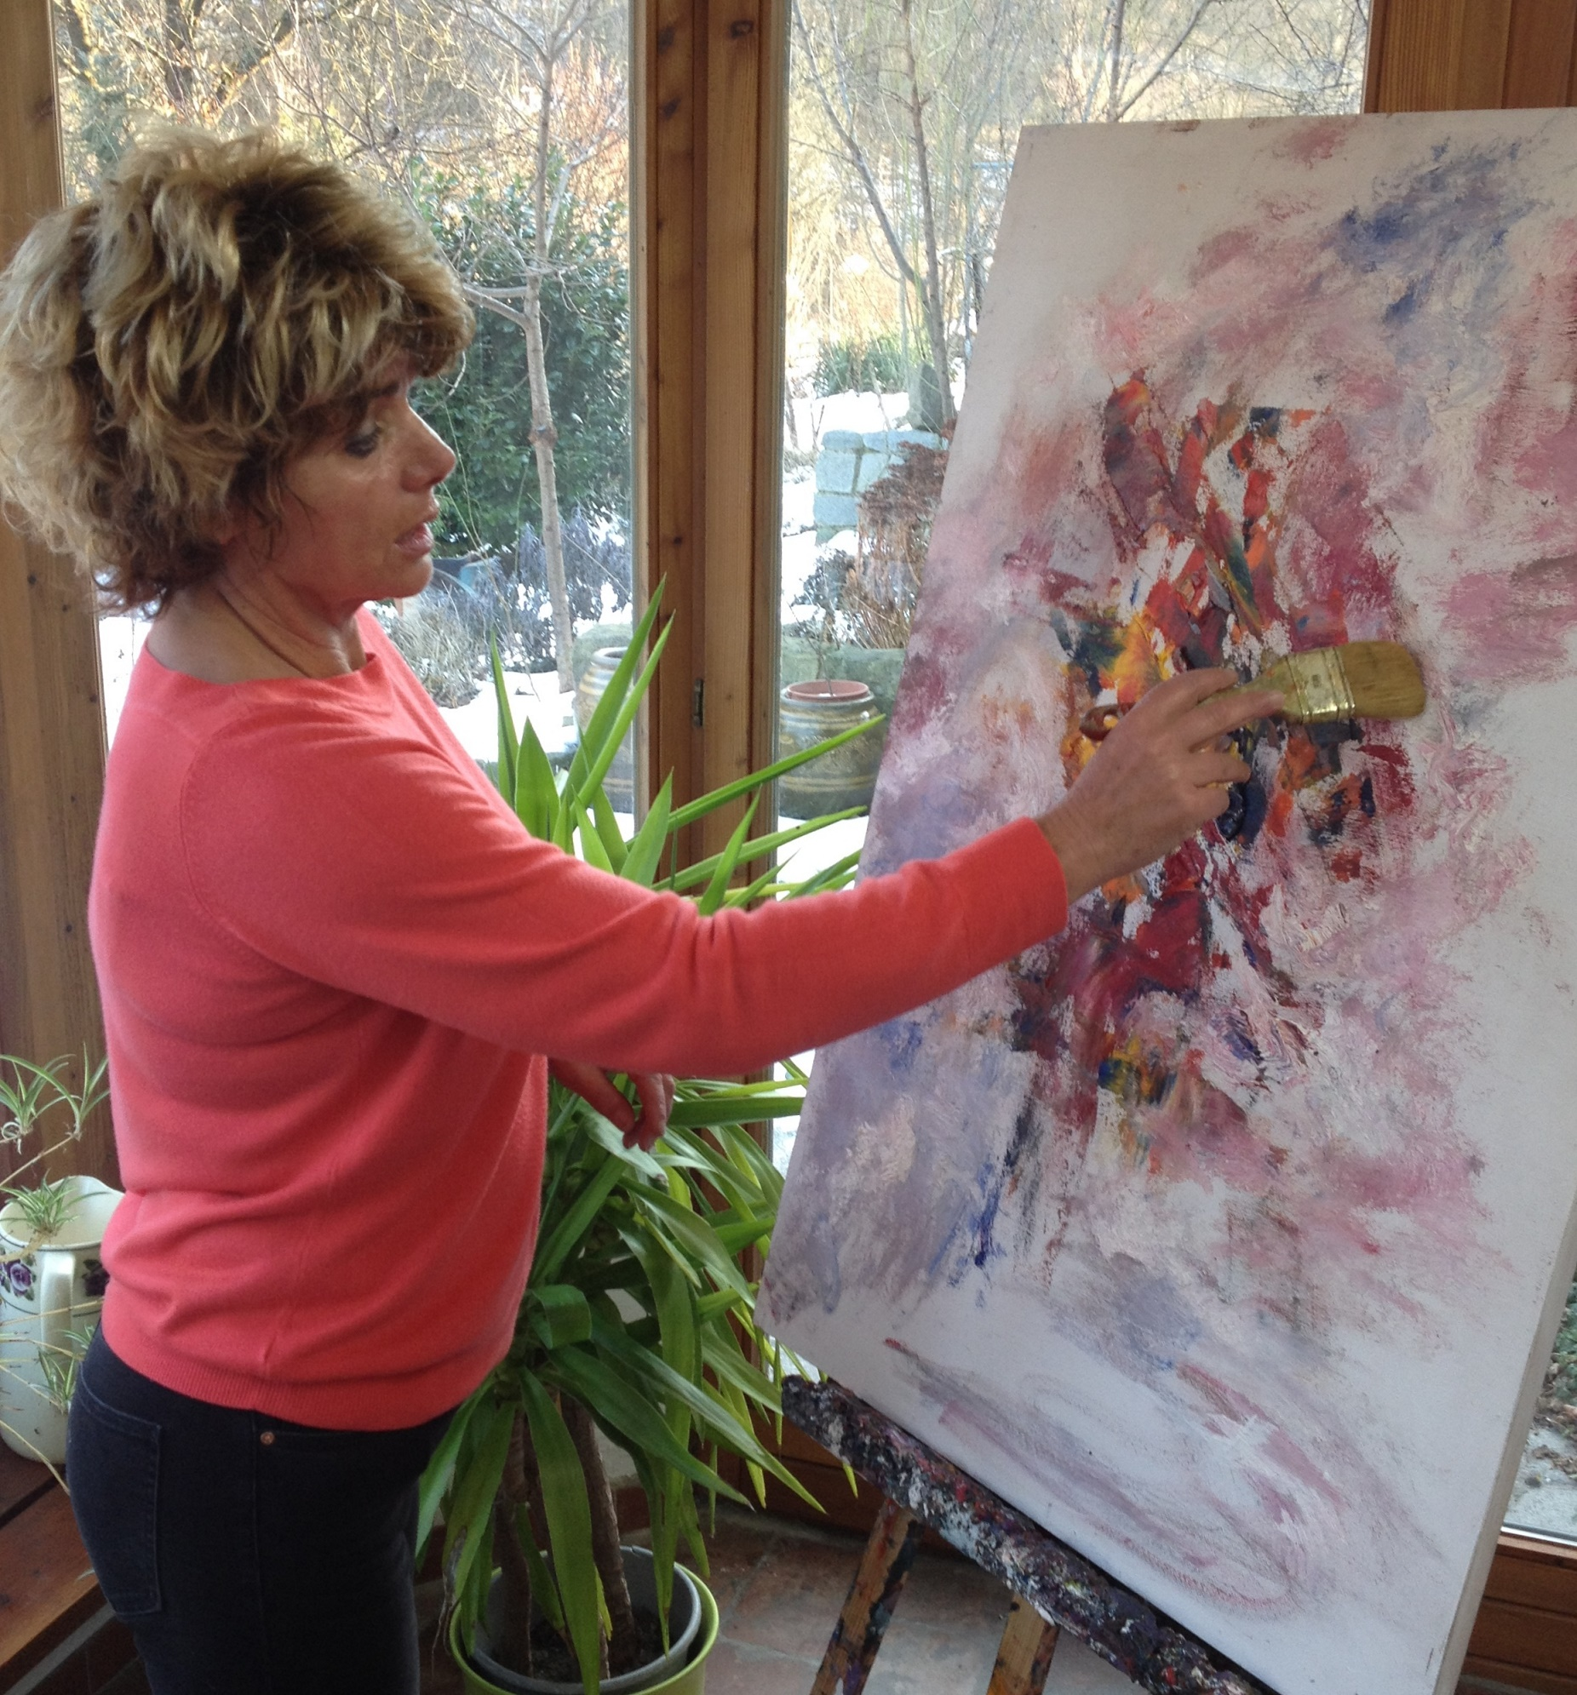
What you see then, are the landscapes of my soul, imaginary seascapes, flowers, or the forests of my mind; and my ghosts and demons – or yours?
Vita
Born in Budapest and graduated at the Budapest Teacher Training College --Budapesti Tanítóképző Főiskola -- with a degree in applied arts and education,
I find pleasure in the music, the movement and the painting which have a developing and therapeutic effect for the children I work with.
The expression of their untainted, child-like creative potential is ever surprising, and sets free the art brut in myself, a raw and abstract expressionism driven by deep feelings, which has since dominated my own painting. Outbursts of form and colours on hardboard or canvas reminiscent of Philip Guston or Judith Reigl, surprise even me with ever new shapes and designs.
Whatever I might have seen in any of my paintings -- people have read them in different ways. So, allow my work to take you through your life experience, follow your feelings and let your dreams run free, find your own title(s) for the painting(s) you like best, and in this way, enjoy the communion with my art as I enjoy the painting.
Permanent exhibition by appointment at Casa Robinia 3400 Kierling, Austria.
casa-robinia@hotmail.com

